**CST-256 Design Report**

|  |  |  |
| --- | --- | --- |
| **Topic:** | Milestone 1 | |
| **Date:** | January 16, 2019 | |
| **Revision:** | 1.0 | |
| **Team:** | 1. Aaron Ross | |
| 1. Tim Wiley | |
|  | |
|  | |
| **Weekly Team Status Summary:** | |  |  |  |  | | --- | --- | --- | --- | | **User Story** | **Team**  **Member** | **Hours**  **Worked** | **Hours Remaining** | | *Create Login and Registration pages* | *Aaron* |  |  | | *Create Home page* | *Aaron* |  |  | | *Create Business Services* | *Tim* | *2* |  | | *Create Data Services* | *Tim* | *2* |  | | *Create Controller* | *Aaron* |  |  | | *Create new routes* | *Aaron* |  |  | | *Create new Database* | *Tim* | *.5* |  | | *Create Sitemap* | *Aaron* |  |  | | *Create Wireframe* | *Aaron* |  |  | | *Create UML diagram* | *Tim* | *1* |  | | *Create ER diagram* | *Tim* | *.1* |  | |  |  |  |  | |  |  |  |  | | |
| **GIT URL:** | https://github.com/twiley6/CST-256-Milestone/invitations | |
| **Hosting URL:** | *The Hosting URL that I can use to access your application.* | |
| **Peer Review:** | *Y/N* | We acknowledge that our team has reviewed this report and we agree to the approach we are all taking. |
| **Screencast URL:** |  | |

**Design Documentation**

**Install Instructions:**

*Include step-by-step instructions for setting up your database, configuring, and deploying/installing your application. This section should also include detailed instructions for what configuration files are required by your application, what configuration settings need to be adjusted for various runtime (development or production) environments, and where the files need to be deployed to. This section should also contain detailed instructions for how to clone your application source code from Bitbucket and deploy the application to an externally hosted site.*

**General Technical Approach:**

*Knowing that this was going to be a similar web application to the popular LinkedIn, we chose to design our User model around the kind of requirements needed for such.*

**Key Technical Design Decisions:**

*We chose to use the connection type PDO in place of the familiar mysqli. .*

**ER Diagram:** 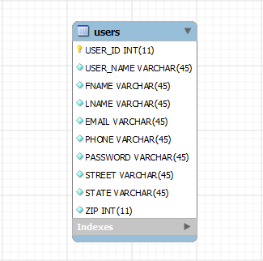

**DDL Scripts:**

*https://github.com/twiley6/CST-256-Milestone/invitations*

**Sitemap Diagram:**

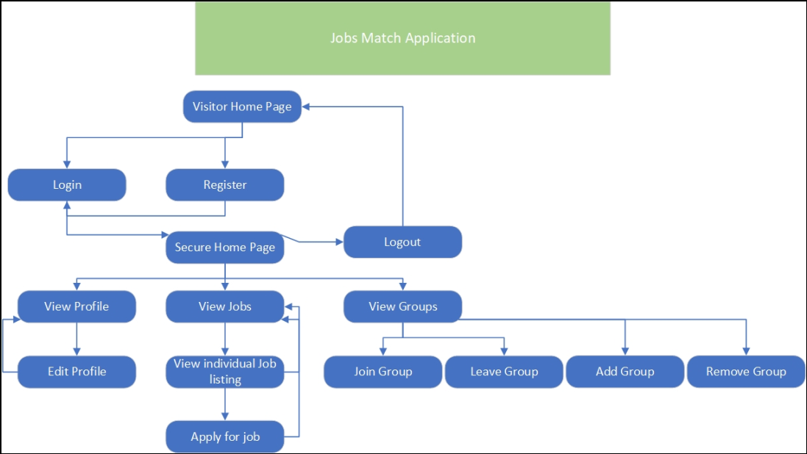

**Security Design:**

*This section should outline the design for how authentication and authorization was supported. This section should also contain all of the roles and privileges that are supported by the design.*

**Third Party Interface Design:**

*This section should fully document any third party service interface APIs, how to access the service, what parameters are required by the API, and the detailed JSON data format specification that could be used by a third-party developer to integrate with the service and API.*

**Flowcharts:**

*Insert any flowcharts here. Flowcharts should document algorithms or workflow that will be implemented in your program. At a minimum, this section should contain a flowchart of your shopping experience.*

**User Interface Diagrams:**  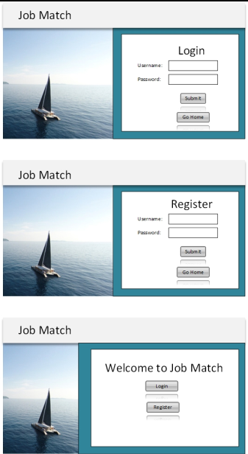

**Class Diagrams:**

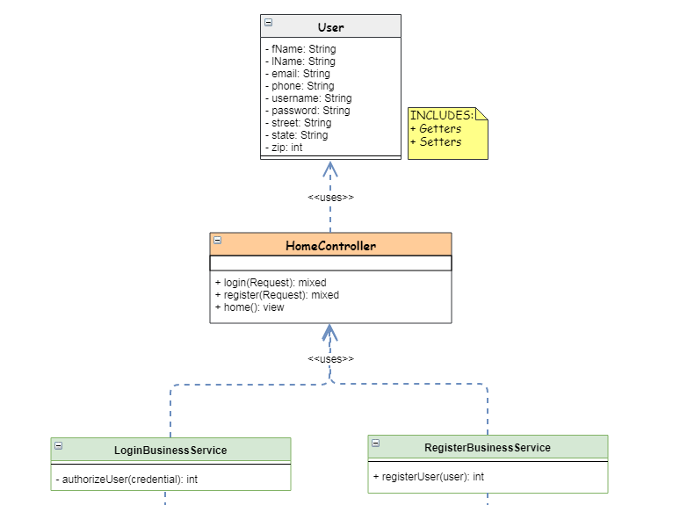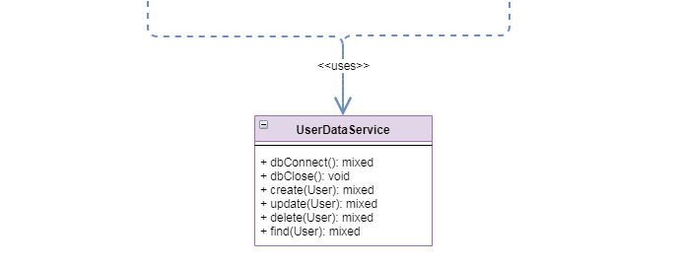

**Pseudo Code:**

*Provide Bitbucket URL references to any code stubs and pseudo code. If you have no supporting documentation, please explain the rationale for leaving this section as N/A.*

**Other Documentation:**

*Insert any additional drawings, storyboards, white board pictures, project schedules, tasks lists, etc. that support your approach, design, and project. If you have no supporting documentation, please explain the rationale for leaving this section as N/A.*